Ex. No. 7 | Persistence Storage with Google Firestore Database
Date of Exercise | 01-11-2025

Github Code Link

Video Link

Aim:
To design and implement a mobile application that demonstrates persistent data storage using the Google Cloud Firestore database, enabling users to store and retrieve data thereby ensuring data remains available even after the application is closed or restarted.
Description:
- Google Cloud Firestore (commonly called Firestore) is a NoSQL document database developed by Google as part of the Firebase platform.
- It is designed for scalable, flexible, and real-time data storage for web, mobile, and server applications.
- Firestore is an evolution of Firebase Realtime Database, offering more powerful querying, better scalability, and a more structured data model.
- Document-Oriented NoSQL Database
  - Data is stored in documents, which are organized into collections.
  - Each document contains key-value pairs and can have nested data like arrays or maps.
Data Model
- Collections: Containers for documents.
- Documents: JSON-like objects with fields (key-value pairs).
- Subcollections: Collections nested within documents for hierarchical data.
Example Structure:
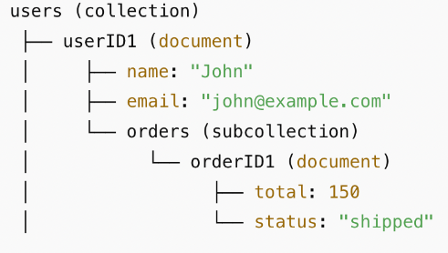
Use Cases
- Chat applications (real-time messaging)
- E-commerce apps (products, orders, inventory)
- Social media apps (feeds, likes, comments)
- Collaborative apps (real-time editing)
- Analytics dashboards with live updates
Integrate Google Firestore Database in Flutter Project
- Install Android Studio
- Create Android Virtual Device (AVD)
- Start the AVD or connect Real Android Device
- Create a Flutter project in VS Code
- Create Google Firebase Project
- Go to Firebase Console.
- Create a new project (or use an existing one).
- Click Add App → Flutter and follow the instructions:
- Download the google-services.json file and place it in android/app/.
Configure the gradle dependencies in Flutter Project
- Project-Level Gradle Settings
- Open build.gradle.kts under the projectdirectory/android folder.
- Configure the buildscript and dependencies as follows:
buildscript {
repositories {
google()
mavenCentral()
}
dependencies {
classpath(“com.google.gms:google-services:4.4.1”)
}
}
- App-Level Gradle Settings
  - Open build.gradle.kts under the projectdirectory/android/app folder.
  - Configure the plugins, ndkVersion, minSdk, and dependencies as shown below:

plugins {
id(“com.google.gms.google-services”) // Add this
}
android {
ndkVersion = “27.0.12077973” // Set NDK version
}
defaultConfig {
minSdk = 23 // Set minimum SDK version
}
//include this dependencies
dependencies {
implementation(platform(“com.google.firebase:firebase-bom:34.3.0”))
}
- Add the Firebase SDK dependencies to your pubspec.yaml as shown below.
dependencies:
flutter:
sdk: flutter
firebase_core: ^3.4.0
cloud_firestore: ^5.4.4

- Enable Cloud Firestore in Firebase Console → Build → Firestore Database → “Create database”.

Start a Collection

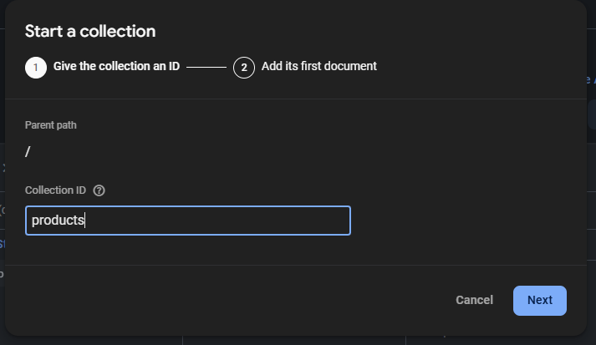

Add New Document
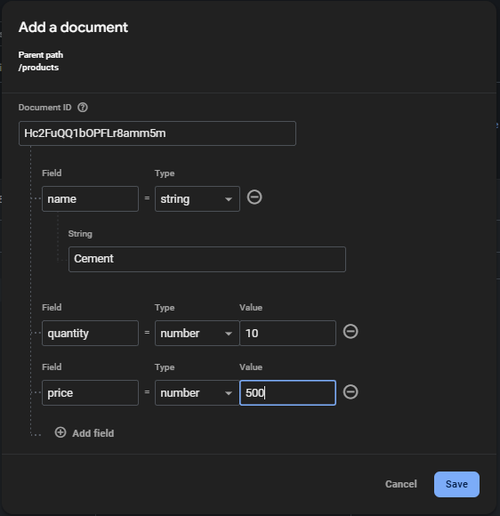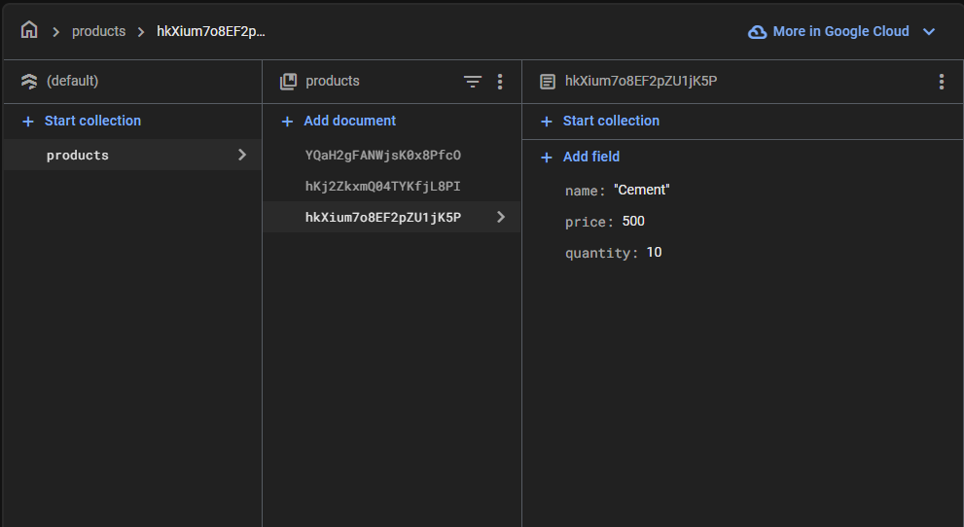

Design the UI Screen to collect user details and implement logic to store the given data in Google Firestore.

Question:
Product Inventory Tracker
Scenario:
A small shop wants to keep track of the products in its inventory.
Requirements:
- Create a table: products (id, name, quantity, price).
- On a single screen, allow the user to:
  - Enter a product’s name, quantity, and price.
  - Save the product into SQLite.
  - Display all products in a ListView below the form.
- Display total stock value = Σ(quantity × price) at the bottom.
- Highlight products where quantity < 5 with a red warning: “Low Stock!”.

Program:
Main.dart
import 'package:flutter/material.dart';
import 'package:firebase_core/firebase_core.dart';
import 'package:cloud_firestore/cloud_firestore.dart';
void main() async{
WidgetsFlutterBinding.ensureInitialized();
await Firebase.initializeApp();
runApp(MaterialApp(
title:"Product Inventory Tracker",
home:ProductScreen(),
));}
class ProductScreen extends StatefulWidget{
const ProductScreen({super.key});
@override
State<ProductScreen> createState()=>_ProductScreenState();
}
class _ProductScreenState extends State<ProductScreen>{
final _formkey=GlobalKey<FormState>();
final _namecontroller=TextEditingController();
final _quantitycontroller=TextEditingController();
final _pricecontroller=TextEditingController();
String _status="";
final CollectionReference product=FirebaseFirestore.instance.collection("products");
Future<void> _addProduct() async{
if(_formkey.currentState!.validate()){
await product.add({
'name':_namecontroller.text,
'quantity':int.parse(_quantitycontroller.text),
'price':int.parse(_pricecontroller.text)
});
_namecontroller.clear();
_quantitycontroller.clear();
_pricecontroller.clear();
setState(() {
_status="Data saved";
}); }}
double gettotal(List<QueryDocumentSnapshot> records) {
double sum = 0;
for (var doc in records) {
sum += (doc['quantity'] * doc['price']); }
return sum;}
@override
Widget build(BuildContext context){
return Scaffold(
appBar:AppBar(title: Text("Product Inventory Tracker"),backgroundColor: Colors.indigo),
body:Container(
padding:EdgeInsets.all(20),
child:Column(
children:[
SingleChildScrollView(
child:Form(
key:_formkey,
child:Column(
children: [
TextFormField(
controller:_namecontroller,
decoration: InputDecoration(
labelText: "Enter product name",
border:OutlineInputBorder(), ),
validator: (value)=>
value==null||value.isEmpty?"Please enter your product name!!":null,
),
SizedBox(height: 10),
TextFormField(
controller:_quantitycontroller,
decoration: InputDecoration(
labelText: "Enter product quantity",
border:OutlineInputBorder(),
),
validator: (value)=>
value==null||value.isEmpty?"Please enter your product quantity!!":null,
),
SizedBox(height: 10),
TextFormField(
controller:_pricecontroller,
decoration: InputDecoration(
labelText: "Enter product price",
border:OutlineInputBorder(),
),
validator: (value)=>
value==null||value.isEmpty?"Please enter your product price!!":null,),
SizedBox(height: 10),
ElevatedButton(
onPressed:_addProduct,
child: Text("Save Details"), ),
SizedBox(height: 10),
Text(_status,style:TextStyle(color:Colors.green))
], ) ),),
SizedBox(height: 10),
Expanded(
child:StreamBuilder<QuerySnapshot>(
stream:product.snapshots(),
builder:(context,snapshot){
if(snapshot.hasError){
return Center(child:Text("Error:${snapshot.error}"));}
if(!snapshot.hasData){
return Center(child:CircularProgressIndicator());}
final records=snapshot.data!.docs;
if(records.isEmpty){
return Center(child:Text("No products found"));}
final total = gettotal(records);
return Column(
children: [
Expanded(child:ListView.builder(
itemCount: records.length,
itemBuilder: (context,index){
final prod =records[index];
return ListTile(
title: Text(prod['name']),
subtitle: Column(
crossAxisAlignment: CrossAxisAlignment.start,
children:[
Text("Quantity: ${prod['quantity'].toString()} price: ${prod['price'].toString()}"),
if(prod['quantity']<5)
const Text("Low Stock!", style:TextStyle(color:Colors.red))
])); },), ),
Padding(
padding :const EdgeInsets.all(8.0),
child:Text("Total Stock value: ${total}",
style:const TextStyle(fontWeight:FontWeight.bold,fontSize:16), )
) ], ); } ) ) ], )
) ); }
}

Output Screenshot:

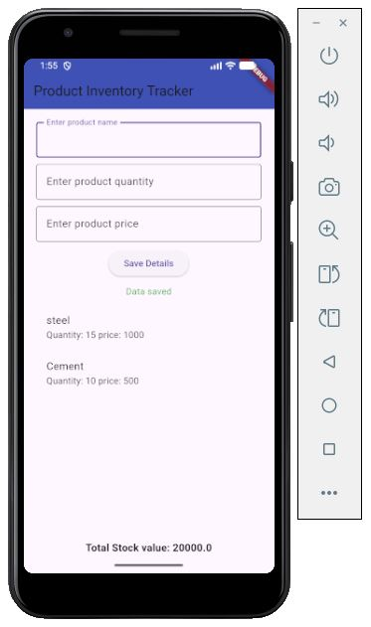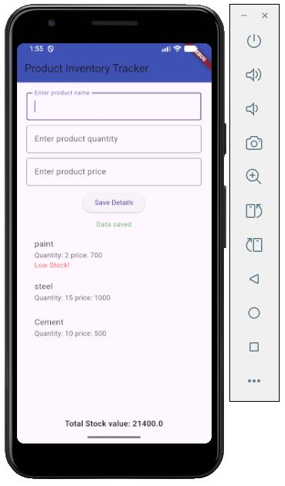

Result:
Thus successfully designed and implemented a mobile application that demonstrates persistent data storage using the Google Cloud Firestore database, enabling users to store and retrieve data thereby ensuring data remains available even after the application is closed or restarted.

